# Math Viva Script

Chapter-one

Indefinite integral: Indefinite integral is the inverse operation to differential calculus.

Substitution Law: $\int{\frac{f'(x)}{f(x)} dx=\ln\left|f(x)\right|+C}$

**Riemann and trapezoidal Sum**

Riemann Sum is a certain kind of approximation of an integral by a **finite** sum. (Approximating the area of function.)

$\begin{aligned}S_{n}=\sum_{r=1}^{n}{f\left(c_{r}\right)\left(x_{r}-x_{r-1}\right)} \\ \\ =\sum_{r=1}^{n}{f\left(c_{r}\right)∆x_{r }, ∆x_{r}=x_{r}-x_{r-1}}\end{aligned}$

## 

Nodal point: Cr (C1,C2,….)

Left Riemann Sum: (Cr=Xr-1) Right: (Cr=Xr) Middle: $(c_{r}=\frac{x_{r-1}+x_{r}}{2})$.

Trapezoidal: average of the heights at end points of the subinterval, it is called the Trapezoidal Riemann sum.

$$f\left(c_{r}\right)=\frac{f\left(x_{r-1}\right)+f(x_{r})}{2},$$

Sub Interval: $∆x=\frac{b-a}{n}$ closed Interval [a, b].

If *f* (-*x*) = *f* (*x*) its even, else its odd *f* (-*x*) =- *f* (*x*)

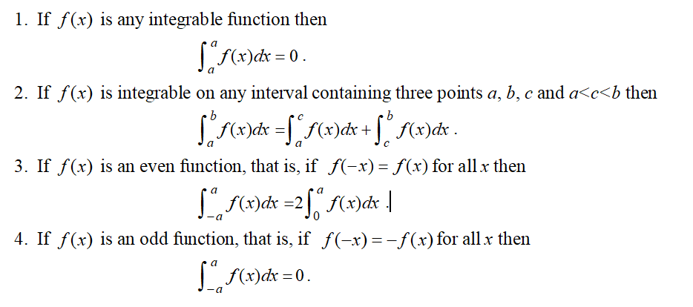

# Chapter-2

## **Area**

Definite integrals could be used to determine the area of the region between the graph of a function and the x-axis or the y-axis.

*c*

|  |  |  |
| --- | --- | --- |
| Area for X-axis |  | *a <=* *x <=* *b* |
| Area for Y-axis | C<= y <= d |  |

Volume

What is Solids of Revolution?

If a region is rotated completely (i.e. through 2π radians) about a straight line, the solid formed is a solid of revolution. Any cross section perpendicular to the axis of rotation is circular.

The volume $ΔV$ of the disc is 

The volume of the solid can be divided into small discs. Summing all the discs as ∆V→ 0 we have the volume of revolution *Vx* , about the X −axis



In the same way, when a region bounded by the curve *x*  *f* (*x*) , , the y-axis and the lines y= c, y =d is rotated about the y-axis, the solid formed has volume



This method is often called method of disks or the method of rings

If we have two function *y*  *f* (*x*) and *y*  *g*(*x*) where *f* (*x*)  *g*(*x*) and bounded by x= a, x= b then volume solid of revolution is about X−axis is given by

$$V_{x}=\int_{a}^{b}{π}{(\left(f\left(x\right)\right)}^{2}-{\left(g\left(x\right)\right)}^{2})dx$$

$$V_{x}=\int_{a}^{b}{π}{(\left(outer radius\right)}^{2}-{\left(outer radius\right)}^{2})dx$$

**Chapter-3**

Improper Integrals

An improper integral is an extended concept of a definite integral that has infinite limits on one or both ends of the interval and/or an integrand that becomes infinite at one or more points within the interval of integration.

Improper integral is called convergent if the limit of the integral exists with finite value and divergent if the limit of the integral does not exist or has infinite value.

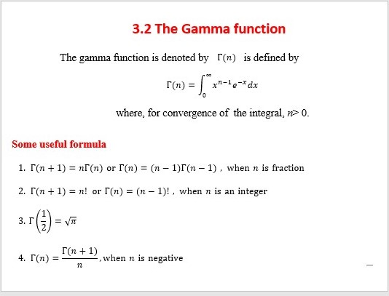

1

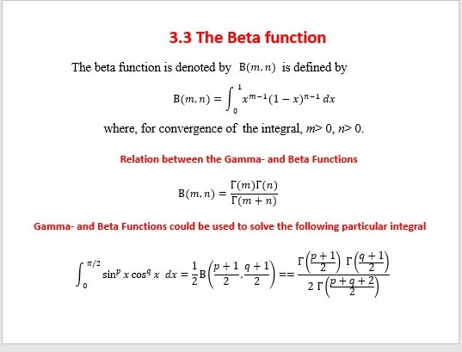

## **Chapter-4**

***integration by Parts***

$$\int{u∙v dx=u\int{v}dx-\int{\left(\frac{du}{dx}\int{v dx}\right)dx}}$$

L= Logarithmic, I=inverse trigonometric, A=Algebraic, T=Trigonometric, E= Exponential

### Necessary Trigonometric Function



$\sin{A}\cos{B}=\frac{1}{2}[\sin{(}A+B)+\sin{(}A-B)]$

$\cos{A}\cos{B}=\frac{1}{2}[\cos{(}A+B)+\cos{(}A-B)]$

$\sin{A}\sin{B}=\frac{1}{2}[\cos{(}A-B)-\cos{(}A+B)]$

Integration of the form  sinm x cosn xdx

### 

What is the cover-up rules?

The cover-up rule is a technique to find the coefficients of linear terms in a partial fraction decomposition. It is a faster technique in finding constants in a partial fraction. We can only apply this rule when the denominator is a product of linear factors.



Point to note: Keily’s method should be used with care if the fraction is improper during the process.

